# ABSTRACT

In recent years, due to the booming development of online social networks, fake news for various commercial and political purposes has been appearing in large numbers and widespread in the online world. With deceptive words, online social network users can get infected by the online fake news easily, which has brought about tremendous effects on the offline society already. An important goal in improving the trustworthiness of information in online social networks is to identify the fake news timely. This paper aims at investigating the principles, methodologies and algorithms for detecting fake news articles, creators and subjects from online social networks and evaluating the corresponding performance. Information preciseness on Internet, especially on social media, is an increasingly important concern, but web-scale data hampers, ability to identify, evaluate and correct such data, or so called "fake news," present in these platforms. In this paper, we propose a method for "fake news" detection and ways to apply it on Facebook, one of the most popular online social media platforms. This method uses Naive Bayes classification model to predict whether a post on Facebook will be labelled as real or fake. The results may be improved by applying several techniques that are discussed in the paper. Received results suggest, that fake news detection problem can be addressed with machine learning methods

**1. INTRODUCTION 1-2**

* 1. MOTIVTION 1
  2. OBJECTIVE 2
  3. OVERVIEW OF THE PROJECT 2

**2. LITERATURE SURVEY 3-7**

* 1. MEDIA RICH FAKE NEWS DETECTION 3
  2. FAKE NEWS DETECTION IN SOCIAL MEDIA 4
  3. THE SPREA OF FAKE NEWS BY SOCIAL BOTS 5
  4. MISLEADING ONLINE CONTENT 6

**3. METHODOLOGY………………………………………………………..8-21**

* 1. EXISTING SYSTEM…………………………………………………………..………...8
  2. PROPOSED SYSTEM………………………………………………………..………….8
  3. SOFTWARE REQUIREMENTS……………………………………………………….10
  4. HARDWARE REQUIREMENTS……………………………………………………...10
  5. SOFTWARE ENVIRONMENT………………………………………………………..10

3.5.1 PYTHON……………………………………………………………..10

3.5.2 PYTHON FEATURES………………………………………………11

3.5.1 INTERACTIVE MODE PROGRAMMING………………………..13

3.5.1 SCRIPT MODE PROGRAMMING…………………………………14

* 1. FLASK FRAMEWORK……………………………………………………………...14
  2. MODULES……………………………………………………………………………19
  3. ALGORITHMS…………………………………………………………………….21

**4. RESULTS AND DISCUSSION 22-33**

* 1. REQUIREMENT ANALYSIS 22
  2. FUNCTIONAL REQUIREMENTS 22
  3. NON- FUNCTIONAL REQUIREMENTS 23
  4. SYSTEM DESIGN AND TESTING PLAN 24
  5. UML 27
  6. TEST PROCEDURE 32

4.6.1 UNIT TESTING 32

4.6.2 INTEGRATION TESTING 32

4.6.3 SYSTEM TESTING 32

4.6.4 FUNCTIONAL TESTING 32

4.6.5 WHITE BOX TESTING 33

4.6.5 ACCEPTANCE TESTING 33

**5. CONCLUSION AND FUTURE WORK** 34

* 1. CONCLUSION……………………………………………………………………..34
  2. FUTURE…………………………………………………………………………….34

**6. REFERENCES………………………….………………………………**35

**7. APPENDIX………………………….………………………………**36

A. SOURCE CODE

B. OUTPUT

**LIST OF FIGURES**

|  |  |  |
| --- | --- | --- |
| **S.NO** | **FIGURE NAME** | **PAGE NUMBER** |
| 1 | ARCHITECTURE DIAGRAM | 9 |
| 2 | LOGIN PAGE | 18 |
| 3 | DASHBORD | 19 |
| 4 | DATA FLOW DIAGRAM | 26 |
| 5 | USE CASE DIAGRAM | 27 |
| 6 | CLASS DIAGRAM | 28 |
| 7 | SEQUENCE DIAGRAM | 29 |
| 8 | ACTIVITY DIAGRAM | 30 |
| 9 | E-R DIAGRAM | 31 |
| 10 | OUTPUT SCREEN | 38 |
| 11 | CHECKING STATEMENT WITH DATASET | 39 |
| 12 | ACCURACY LEVEL OF ALGORITMS WITH DATASET | 30 |

**CHAPTER 1**

# INTRODUCTION

These days‟ fake news is creating different issues from sarcastic articles to a fabricated news and plan government propaganda in some outlets. Fake news and lack of trust in the media are growing problems with huge ramifications in our society. Obviously, a purposely misleading story is “fake news “but lately blathering social media’s discourse is changing its definition. Some of them now use the term to dismiss the facts counter to their preferred viewpoints.

The importance of disinformation within American political discourse was the subject of weighty attention, particularly following the American president election. The term 'fake news' became common parlance for the issue, particularly to describe factually incorrect and misleading articles published mostly for the purpose of making money through page views. In this paper, it is seeked to produce a model that can accurately predict the likelihood that a given article is fake news. Facebook has been at the epicenter of much critique following media attention. They have already implemented a feature to flag fake news on the site when a user see’s it; they have also said publicly they are working on to to distinguish these articles *in* an automated way. Certainly, it is not an easy task. A given algorithm must be politically unbiased – since fake news exists on both ends of the spectrum – and also give equal balance to legitimate news sources on either end of the spectrum. In addition, the question of legitimacy is a difficult one. However, in order to solve this problem, it is necessary to have an understanding on what Fake News.

# 1.1 MOTIVATION

We will be training and testing the data, when we use supervised learning it means we are labelling the data. By getting the testing and training data and labels we can perform different machine learning algorithms but before performing the predictions and accuracies, the data is need to be pre-processing i.e. the null values which are not readable are required to be removed from the data set and the data is required to be converted into vectors by normalizing and tokening the data so that it could be understood by the machine. Next step is by using this data, getting the visual reports, which we will get by using the Mat Plot Library of Python and Sickit Learn. This library helps us in getting the results in the form of histograms, pie charts or bar charts.

# 1.2 OBJECTIVE

The objective of this project is to examine the problems and possible significances related with the spread of fake news. We will be working on different fake news data set in which we will apply different machine learning algorithms to train the data and test it to find which news is the real news or which one is the fake news. As the fake news is a problem that is heavily affecting society and our perception of not only the media but also facts and opinions themselves. By using the artificial intelligence and the machine learning, the problem can be solved as we will be able to mine the patterns from the data to maximize well defined objectives. So, our focus is to find which machine learning algorithm is best suitable for what kind of text dataset. Also, which dataset is better for finding the accuracies as the accuracies directly depends on the type of data and the amount of data. The more the data, more are your chances of getting correct accuracy as you can test and train more data to find out your results.

# 1.3 OVERVIEW OF PROJECT

With the advancement of technology, digital news is more widely exposed to users globally and contributes to the increment of spreading and disinformation online. Fake news can be found through popular platforms such as social media and the Internet. There have been multiple solutions and efforts in the detection of fake news where it even works with tools. However, fake news intends to convince the reader to believe false information which deems these articles difficult to perceive. The rate of producing digital news is large and quick, running daily at every second, thus it is challenging for machine learning to effectively detect fake news

**CHAPTER 2**

# LITERATURE SURVEY

The available literature has described many automatic detection techniques of fake news and deception posts. Since there are multidimensional aspects of fake news detection ranging from using chatbots for spread of misinformation to use of clickbaits for the rumor spreading. There are many clickbaits available in social media networks including facebook which enhance sharing and liking Proceedings of posts which in turn spreads falsified information. Lot of work has been done to detect falsified information.

# MEDIA RICH FAKE NEWS DETECTION: A SURVEY

In general, the goal is profiting through clickbaits. Clickbaits lure users and entice curiosity with flashy headlines or designs to click links to increase advertisements revenues. This exposition analyzes the prevalence of fake news in light of the advances in communication made possible by the emergence of social networking sites. The purpose of the work is to come up with a solution that can be utilized by users to detect and filter out sites containing false and misleading information. We use simple and carefully selected features of the title and post to accurately identify fake posts. The experimental results show a 99.4% accuracy using logistic classifier.

# WEAKLY SUPERVISED LEARNING FOR FAKE NEWS DETECTION ON

# TWITTER

The problem of automatic detection of fake news in social media, e.g., on Twitter, has recently drawn some attention. Although, from a technical perspective, it can be regarded as a straight-forward, binary classification problem, the major challenge is the collection of large enough training corpora, since manual annotation of tweets as fake or non-fake news is an expensive and tedious endeavor. In this paper, we discuss a weakly supervised approach, which automatically collects a large-scale, but very noisy training dataset comprising hundreds of thousands of tweets. During collection, we automatically label tweets by their source, i.e., trustworthy or untrustworthy source, and train a classifier on this dataset. We then use that classifier for a different classification target, i.e., the classification of fake and no fake tweets. Although the labels are not accurate according to the new classification target (not all tweets by an untrustworthy source need to be fake news, and vice versa), we show that despite this unclean inaccurate dataset, it is possible to detect fake news with an F1 score of up to 0.9.

# FAKE NEWS DETECTION IN SOCIAL MEDIA

Fake news and hoaxes have been there since before the advent of the Internet. The widely accepted definition of Internet fake news is: fictitious articles deliberately fabricated to deceive readers”. Social media and news outlets publish fake news to increase readership or as part of psychological warfare. In general, the goal is profiting through clickbaits. Clickbaits lure users and entice curiosity with flashy headlines or designs to click links to increase advertisements revenues. This exposition analyses the prevalence of fake news in light of the advances in communication made possible by the emergence of social networking sites. The purpose of the work is to come up with a solution that can be utilized by users to detect and filter out sites containing false and misleading information. We use simple and carefully selected features of the title and post to accurately identify fake posts.

The experimental results show a 99.4% accuracy using logistic classifier.

## Automatic Online Fake News Detection Combining Content and Social Signals

The proliferation and rapid diffusion of fake news on the Internet highlight the need of automatic hoax detection systems. In the context of social networks, machine learning (ML) methods can be used for this purpose. Fake news detection strategies are traditionally either based on content analysis (i.e. analysing the content of the news) or - more recently - on social context models, such as mapping the news‟ diffusion pattern. In this paper, we first propose a novel ML fake news detection method which, by combining news content and social context features, outperforms existing methods in the literature, increasing their already high accuracy by up to 4.8%. Second, we implement our method within a Facebook Messenger chatbot and validate it with a real-world application, obtaining a fake news detection accuracy of

81.7%.

In recent years, the reliability of information on the Internet has emerged as a crucial issue of modern society. Social network sites (SNSs) have revolutionized the way in which information is spread by allowing users to freely share content. As a consequence, SNSs are also increasingly used as vectors for the diffusion of misinformation and hoaxes. The amount of disseminated information and the rapidity of its diffusion make it practically impossible to assess reliability in a timely manner, highlighting the need for automatic hoax detection systems. As a contribution towards this objective, we show that Facebook posts can be classified with high accuracy as hoaxes or non-hoaxes on the basis of the users who "liked" them. We present two classification techniques, one based on logistic regression, the other on a novel adaptation of Boolean crowdsourcing algorithms. On a dataset consisting of 15,500 Facebook posts and 909,236 users, we obtain classification accuracies exceeding 99% even when the training set contains less than 1% of the posts. We further show that our techniques are robust: they work even when we restrict our attention to the users who like both hoax and non-hoax posts. These results suggest that mapping the diffusion pattern of information can be a useful component of automatic hoax detection systems.

# THE SPREAD OF FAKE NEWS BY SOCIAL BOTS

The massive spread of fake news has been identified as a major global risk and has been alleged to influence elections and threaten democracies. Communication, cognitive, social, and computer scientists are engaged in efforts to study the complex causes for the viral diffusion of digital misinformation and to develop solutions, while search and social media platforms are beginning to deploy countermeasures. However, to date, these efforts have been mainly informed by anecdotal evidence rather than systematic data. Here we analyse 14 million messages spreading 400 thousand claims on Twitter during and following the 2016 U.S. presidential campaign and election. We find evidence that social bots play a key role in the spread of fake news. Accounts that actively spread misinformation are significantly more likely to be bots. Automated accounts are particularly active in the early spreading phases of viral claims, and tend to target influential users. Humans are vulnerable to this manipulation, retweeting bots who post false news. Successful sources of false and biased claims are heavily supported by social bots. These results suggest that curbing social bots may be an effective strategy for mitigating the spread of online misinformation.

# MISLEADING ONLINE CONTENT

Tabloid journalism is often criticized for its propensity for exaggeration, sensationalization, scare-mongering, and otherwise producing misleading and low quality news. As the news has moved online, a new form of tabloidization has emerged: clickbaiting ‟Clickbait‟ refers to “content whose main purpose is to attract attention and encourage visitors to click on a link to a particular web page” [„clickbait,‟ n.d.] and has been implicated in the rapid spread of rumour and misinformation online. This paper examines potential methods for the automatic detection of clickbait as a form of deception. Methods for recognizing both textual and non-textual clickbaiting cues are surveyed, leading to the suggestion that a hybrid approach may yield best results.

Big Data Analytics and Deep Learning are two high-focus of data science. Big Data has become important as many organizations both public and private have been collecting massive amounts of domain-specific information, which can contain useful information about problems such as national intelligence, cyber security, fraud detection, marketing, and medical informatics. Companies such as Google and Microsoft are analysing large volumes of data for business analysis and decisions, impacting existing and future technology. Deep Learning algorithms extract highlevel, complex abstractions as data representations through a hierarchical learning process. Complex abstractions are learnt at a given level based on relatively simpler abstractions formulated in the preceding level in the hierarchy. A key benefit of Deep Learning is the analysis and learning of massive amounts of unsupervised data, making it a valuable tool for Big Data Analytics where raw data is largely unlabelled and un-categorized. In the present study, we explore how Deep Learning can be utilized for addressing some important problems in Big Data Analytics, including extracting complex patterns from massive volumes of data, semantic indexing, data tagging, fast information retrieval, and simplifying discriminative tasks. We also investigate some aspects of Deep Learning research that need further exploration to incorporate specific challenges introduced by Big Data Analytics, including streaming data, high-dimensional data, scalability of models, and distributed computing. We conclude by presenting insights into relevant future works by posing some questions, including defining data sampling criteria, domain adaptation modelling, defining criteria for obtaining useful data abstractions, improving semantic indexing, semi - supervised learning, and active learning.

**CHAPTER 3**

**METHODOLOGY**

# 3.1 EXISTING SYSTEM

There exists a large body of research on the topic of machine learning methods for deception detection, most of it has been focusing on classifying online reviews and publicly available social media posts. Particularly since late 2016 during the American Presidential election, the question of determining 'fake news' has also been the subject of particular attention within the literature. Conroy, Rubin, and Chen outlines several approaches that seem promising towards the aim of perfectly classify the misleading articles. They note that simple content-related n-grams and shallow parts-of-speech tagging have proven insufficient for the classification task, often failing to account for important context information. Rather, these methods have been shown useful only in tandem with more complex methods of analysis. Deep Syntax analysis using Probabilistic Context Free Grammars have been shown to be particularly valuable in combination with n-gram methods. Feng, Banerjee, and Choi are able to achieve 85%-91% accuracy in deception related classification tasks using online review corpora.

# 3.2 PROPOSED SYSTEM

In this paper a model is build based on the count vectorizer or a tfidf matrix (i.e. word tallies relatives to how often they are used in other articles in your dataset) can help. Since this problem is a kind of text classification, implementing a Naive Bayes classifier will be best as this is standard for text-based processing. The actual goal is in developing a model which was the text transformation (count vectorizer vs tfidf-vectorizer) and choosing which type of text to use (headlines vs full text). Now the next step is to extract the most optimal features for countvectorizer or tfidf-vectorizer, this is done by using a n-number of the most used words, and/or phrases, lower casing or not, mainly removing the stop words which are common words such as “the”, “when”, and “there” and only using those words that appear at least a given number of times in a given text dataset.

# SYSTEM ARCHITECTURE

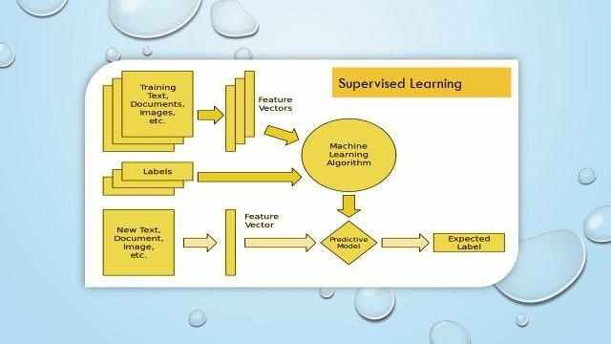

Fig:3.1 Architecture diagram

# 

**3.3 HARDWARE REQUIREMENTS:**

System : Intel i3 2.2Ghz

Hard Disk : 320GB.

Ram : 8 GB.

**3.4 SOFTWARE REQUIREMENTS:**

Operating system : Windows 8 Ultimate.

Coding Language : Python 3.11.9.

IDE : VS Code Editor/ any other code editor.

Libraries : Flask, Scikit-Learn, Torch, Numpy, Pandas,Matplotlib

Seaborn**.**

**3.5 SOFTWARE ENVIRONMENT**

# 3.5.1 PYTHON

Python is a high-level, interpreted, interactive and object-oriented scripting language. Python is designed to be highly readable. It uses English keywords frequently where as other languages use punctuation, and it has fewer syntactical constructions than other languages.

* **Python is Interpreted** − Python is processed at runtime by the interpreter.

You do not need to compile your program before executing it. This is similar to PERL and PHP.

* **Python is Interactive** − You can actually sit at a Python prompt and interact with the interpreter directly to write your programs.
* **Python is Object-Oriented** − Python supports Object-Oriented style or technique of programming that encapsulates code within objects.
* **Python is a Beginner's Language** − Python is a great language for the beginner-level programmers and supports the development of a wide range of applications from simple text processing to WWW browsers to games.

## History of Python

Python was developed by Guido van Rossum in the late eighties and early nineties at the National Research Institute for Mathematics and Computer Science in the Netherlands.

Python is derived from many other languages, including ABC, Modula-3, C, C++, Algol-68, Smalltalk, and Unix shell and other scripting languages.

Python is copyrighted. Like Perl, Python source code is now available under the GNU General Public License (GPL).

Python is now maintained by a core development team at the institute, although Guido van Rossum still holds a vital role in directing its progress.

# PYTHON FEATURES

Python's features include −

* **Easy-to-learn** − Python has few keywords, simple structure, and a clearly

defined syntax. This allows the student to pick up the language quickly.

* **Easy-to-read** − Python code is more clearly defined and visible to the eyes.
* **Easy-to-maintain** − Python's source code is fairly easy-to-maintain.

* **A broad standard library** − Python's bulk of the library is very portable and cross-platform compatible on UNIX, Windows, and Macintosh.
* **Interactive Mode** − Python has support for an interactive mode which allows interactive testing and debugging of snippets of code.
* **Portable** − Python can run on a wide variety of hardware platforms and has the same interface on all platforms.
* **Extendable** − You can add low-level modules to the Python interpreter.

These modules enable programmers to add to or customize their tools to be more efficient.

* **Databases** − Python provides interfaces to all major commercial databases.

* **GUI Programming** − Python supports GUI applications that can be created and ported to many system calls, libraries and windows systems, such as Windows MFC, Macintosh, and the X Window system of Unix.
* **Scalable** − Python provides a better structure and support for large programs

than shell scripting.

Apart from the above-mentioned features, Python has a big list of good features, few are listed below −

* It supports functional and structured programming methods as well as OOP.

* It can be used as a scripting language or can be compiled to byte-code for building large applications.
* It provides very high-level dynamic data types and supports dynamic type checking.
* It supports automatic garbage collection.
* It can be easily integrated with C, C++, COM, ActiveX, CORBA, and Java.

Python is available on a wide variety of platforms including Linux and Mac OS X.

Let's understand how to set up our Python environment.

## Getting Python

The most up-to-date and current source code, binaries, documentation, news, etc., is available on the official website of Python [https://www.python.org.](https://www.python.org/)

Windows Installation

Here are the steps to install Python on Windows machine.

1. Open a Web browser and go to [https://www.python.org/downloads/.](https://www.python.org/downloads/)

1. Follow the link for the Windows installer python-XYZ msifile where XYZ is the version you need to install.
2. To use this installer python-XYZ.msi, the Windows system must support Microsoft Installer 2.0. Save the installer file to your local machine and then run it to find out if your machine supports MSI.
3. Run the downloaded file. This brings up the Python install wizard, which is really easy to use. Just accept the default settings, wait until the install is finished, and you are done.

The Python language has many similarities to Perl, C, and Java. However, there are some definite differences between the languages.

# INTERACTIVE MODE PROGRAMMING

Invoking the interpreter without passing a script file as a parameter brings up the following prompt −

## $ python

Python2.4.3(#1,Nov112010,13:34:43)

[GCC 4.1.220080704(RedHat4.1.2-48)] on linux2

Type"help","copyright","credits"or"license"for more information.

>>>

Type the following text at the Python prompt and press the Enter −

>>>print"Hello, Python!"

If you are running new version of Python, then you would need to use print statement with parenthesis as in **print ("Hello, Python!");** However in Python version 2.4.3, this produces the following result −

Hello, Python!

# SCRIPT MODE PROGRAMMING

Invoking the interpreter with a script parameter begins execution of the script and continues until the script is finished. When the script is finished, the interpreter is no longer active.

Let us write a simple Python program in a script. Python files have extension **.py**.

Type the following source code in a test.py file −

print"Hello, Python!"

We assume that you have Python interpreter set in PATH variable. Now, try to run this program as follows −

## $ python test.py

This produces the following result −

Hello, Python!

# FLASK FRAMEWORK

Flask is a web application framework written in Python. Armin Ronacher, who leads an international group of Python enthusiasts named Pocco, develops it. Flask is based on Werkzeug WSGI toolkit and Jinja2 template engine. Both are Pocco projects.

Http protocol is the foundation of data communication in world wide web. Different methods of data retrieval from specified URL are defined in this protocol.

The following table summarizes different http methods −

|  |  |
| --- | --- |
| **S.No** | **Methods & Description** |
| 1 | **GET**    Sends data in unencrypted form to the server. Most common method. |
| 2 | **HEAD**    Same as GET, but without response body |
| 3 | **POST**    Used to send HTML form data to server. Data received by POST method is not cached by server. |
| 4 | **PUT**    Replaces all current representations of the target resource with the uploaded content. |
| 5 | **DELETE**    Removes all current representations of the target resource given by a URL |

By default, the Flask route responds to the **GET** requests. However, this preference can be altered by providing methods argument to **route ()** decorator.

In order to demonstrate the use of **POST** method in URL routing, first let us create an HTML form and use the **POST** method to send form data to a URL.

Save the following script as login.html

<html>

<body>

<formaction="http://localhost:5000/login"method="post">

## <p>Enter Name:</p>

<p><inputtype="text"name="nm"/></p>

<p><inputtype="submit" value="submit"/></p>

</form>

</body>

</html>

Now enter the following script in Python shell.

from flask importFlask, redirect,url_for, request

## app=Flask( name )

|  |
| --- |
| @app.route('/success/<name>') def success(name):  return'welcome %s'% name  @app.route('/login',methods=['POST','GET'])  def login():  ifrequest.method=='POST': user=request.form['nm'] return redirect(url_for('success',name= user)) else: user=request.args.get('nm')  return redirect(url_for('success',name= user))  if name ==' main ':  app.run(debug =True) |

After the development server starts running, open **login.html** in the browser, enter name in the text field and click **Submit**

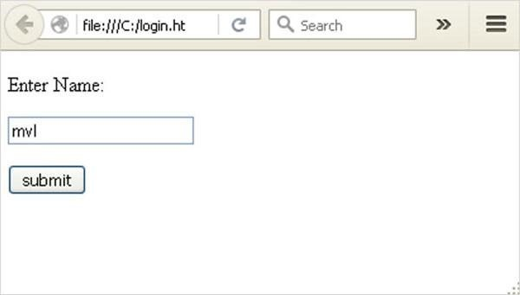

### Fig:3.2 Login page

Form data is posted to the URL in action clause of form tag.

[**http://localhost/login**is](http://localhost/login) mapped to the **login()** function. Since the server has received data by **POST** method, value of „nm‟ parameter obtained from the form data is obtained by −

## user = request.form['nm']

It is passed to **„/success‟** URL as variable part. The browser displays a **welcome** message in the window.

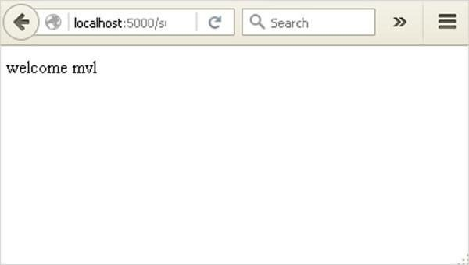

### Fig:3.3 Dashboard

Change the method parameter to **“GET‟** in **login.html** and open it again in the browser. The data received on server is by the **GET** method. The value of „nm‟ parameter is now obtained by −

## User = request.args.get(„nm‟)

Here, **args** is dictionary object containing a list of pairs of form parameter and its corresponding value. The value corresponding to „nm‟ parameter is passed on to

„/success‟ URL as before.

# MODULES

1. Data Use
2. Pre-processing
3. Feature Extraction
4. Training the Classifier

# MODULES DESCRIPTION

# A. Data Use

So, in this project we are using different packages and to load and read the data set we are using pandas. By using pandas, we can read the .csv file and then we can display the shape of the dataset with that we can also display the dataset in the correct form. We will be training and testing the data, when we use supervised learning it means we are labelling the data. By getting the testing and training data and labels we can perform different machine learning algorithms but before performing the predictions and accuracies, the data is need to be pre-processing i.e. the null values which are not readable are required to be removed from the data set and the data is required to be converted into vectors by normalizing and tokening the data so that it could be understood by the machine. Next step is by using this data, getting the visual reports, which we will get by using the Mat Plot Library of Python and Sickit Learn. This library helps us in getting the results in the form of histograms, pie charts or bar charts.

# B. Pre-processing

The data set used is split into a training set and a testing set containing in Dataset 1

-3256 training data and 814 testing data and in Dataset II- 1882 training data and 471 testing data respectively. Cleaning the data is always the first step. In this, those words are removed from the dataset. That helps in mining the useful information. Whenever we collect data online, it sometimes contains the undesirable characters like stop words, digits etc. which creates hindrance while spam detection. It helps in removing the texts which are language independent entities and integrate the logic which can improve the accuracy of the identification task.

## C. Feature Extraction

Feature extraction s the process of selecting a subset of relevant features for use in model construction. Feature extraction methods helps in to create an accurate predictive model. They help in selecting features that will give better accuracy. When the input data to an algorithm is too large to be handled and i ts supposed to be redundant then the input data will be transformed into a reduced illustration set of features also named feature vectors. Altering the input data to perform the desired task using this reduced representation instead of the full-size input. Feature extraction is performed on raw data prior to applying any machine learning algorithm, on the transformed data in feature space.

## D. Training the Classifier

As in this project I am using Scikit-Learn Machine learning library for implementing the architecture. Scikit Learn is an open source python Machine Learning library which comes bundled in 3rd distribution anaconda. This just needs importing the packages and you can compile the command as soon as you write it. If the command doesn’t run, we can get the error at the same time. I am using 4 different algorithms and I have trained these 4 models i.e. Naïve Bayes, Support Vector Machine, K Nearest Neighbours and Logistic Regression wic are very popular methods for document classification problem. Once the classifiers are trained, we can check the performance of the models on test-set. We can extract the word count vector for each mail in test-set and predict it class with the trained models.

# ALGORITHMS

## Naive Bayes

* One of supervised learning algorithm based on probabilistic classification technique.
* It is a powerful and fast algorithm for predictive modelling.
* In this project, I have used the Multinomial Naive Bayes Classifier.

## Support Vector Machine- SVM

* SVM’s are a set of supervised learning methods used for classification, and regression.
* Effective in high dimensional spaces.
* Uses a subset of training points in the support vector, so it is also memory efficient.

## Logistic Regression

* Linear model for classification rather than regression.
* The expected values of the response variable are modelled based on combination of

**CHAPTER 4**

# RESULTS AND DISCUSSION

* Algorithm’s accuracy depends on the type and size of your dataset. More the data, more chances of getting correct accuracy.
* Machine learning depends on the variations and relations.
* Understanding what is predictable is as important as trying to predict it.
* While making algorithm choice, speed should be a consideration factor.

# REQUIREMENT ANALYSIS

Requirement analysis, also called requirement engineering, is the process of determining user expectations for a new modified product. It encompasses the tasks that determine the need for analysing, documenting, validating and managing software or system requirements. The requirements should be documentable, actionable, measurable, testable and traceable related to identified business needs or opportunities and define to a level of detail, sufficient for system design.

# FUNCTIONAL REQUIREMENTS

It is a technical specification requirement for the software products. It is the first step in the requirement analysis process which lists the requirements of particular software systems including functional, performance and security requirements. The function of the system depends mainly on the quality hardware used to run the software with given functionality.

## Usability

It specifies how easy the system must be use. It is easy to ask queries in any format which is short or long, porter stemming algorithm stimulates the desired response for user.

## Robustness

It refers to a program that performs well not only under ordinary conditions but also under unusual conditions. It is the ability of the user to cope with errors for irrelevant queries during execution.

## Security

The state of providing protected access to resource is security. The system provides good security and unauthorized users cannot access the system there by providing high security.

## Reliability

It is the probability of how often the software fails. The measurement is often expressed in MTBF (Mean Time Between Failures). The requirement is needed in order to ensure that the processes work correctly and completely without being aborted. It can handle any load and survive and survive and even capable of working around any failure.

## Compatibility

It is supported by version above all web browsers. Using any web servers like localhost makes the system real-time experience.

## Flexibility

The flexibility of the project is provided in such a way that is has the ability to run on different environments being executed by different users.

## Safety

Safety is a measure taken to prevent trouble. Every query is processed in a secured manner without letting others to know one’s personal information.

# NON- FUNCTIONAL REQUIREMENTS

## Portability

It is the usability of the same software in different environments. The project can be run in any operating system.

## Performance

These requirements determine the resources required, time interval, throughput and everything that deals with the performance of the system.

## Accuracy

The result of the requesting query is very accurate and high speed of retrieving information. The degree of security provided by the system is high and effective.

## Maintainability

Project is simple as further updates can be easily done without affecting its stability. Maintainability basically defines that how easy it is to maintain the system. It means that how easy it is to maintain the system, analyse, change and test the application. Maintainability of this project is simple as further updates can be easily done without affecting its stability.

**SYSTEM DESIGN AND TESTING PLAN**

# INPUT DESIGN

The input design is the link between the information system and the user. It comprises the developing specification and procedures for data preparation and those steps are necessary to put transaction data in to a usable form for processing can be achieved by inspecting the computer to read data from a written or printed document or it can occur by having people keying the data directly into the system. The design of input focuses on controlling the amount of input required, controlling the errors, avoiding delay, avoiding extra steps and keeping the process simple. The input is designed in such a way so that it provides security and ease of use with retaining the privacy. Input Design considered the following things:

1. What data should be given as input?
2. How the data should be arranged or coded?
3. The dialog to guide the operating personnel in providing input.
4. Methods for preparing input validations and steps to follow when error occur.

# OUTPUT DESIGN

A quality output is one, which meets the requirements of the end user and presents the information clearly. In any system results of processing are communicated to the users and to other system through outputs. In output design it is determined how the information is to be displaced for immediate need and also the hard copy output. It is the most important and direct source information to the user. Efficient and intelligent output design improves the system’s relationship to help user decision-making.

The output form of an information system should accomplish one or more of the following objectives.

* Convey information about past activities, current status or projections of the 
* Future.
* Signal important events, opportunities, problems, or warnings.
* Trigger an action.
* Confirm an action.

# SOCIAL FEASIBILITY

# 

The aspect of study is to check the level of acceptance of the system by the user. This includes the process of training the user to use the system efficiently. The user must not feel threatened by the system, instead must accept it as a necessity. The level of acceptance by the users solely depends on the methods that are employed to educate the user about the system and to make him familiar with it. His level of confidence must be raised so that he is also able to make some constructive criticism, which is welcomed, as he is the final user of the system.

# DATA FLOW DIAGRAM

* The DFD is also called as bubble chart. It is a simple graphical formalism that can be used to represent a system in terms of input data to the system, various processing carried out on this data, and the output data is generated by this system.
* The data flow diagram (DFD) is one of the most important modelling tools. It is used to model the system components. These components are the system process, the data used by the process, an external entity that interacts with the system and the information flows in the system.
* DFD shows how the information moves through the system and how it is modified by a series of transformations. It is a graphical technique that depicts information flow and the transformations that are applied as data moves from input to output.
* DFD is also known as bubble chart. A DFD may be used to represent a system at any level of abstraction. DFD may be partitioned into levels that represent increasing information flow and functional detail.
* It is the testing of individual software units of the application .it is done after the completion of an individual unit before integration.

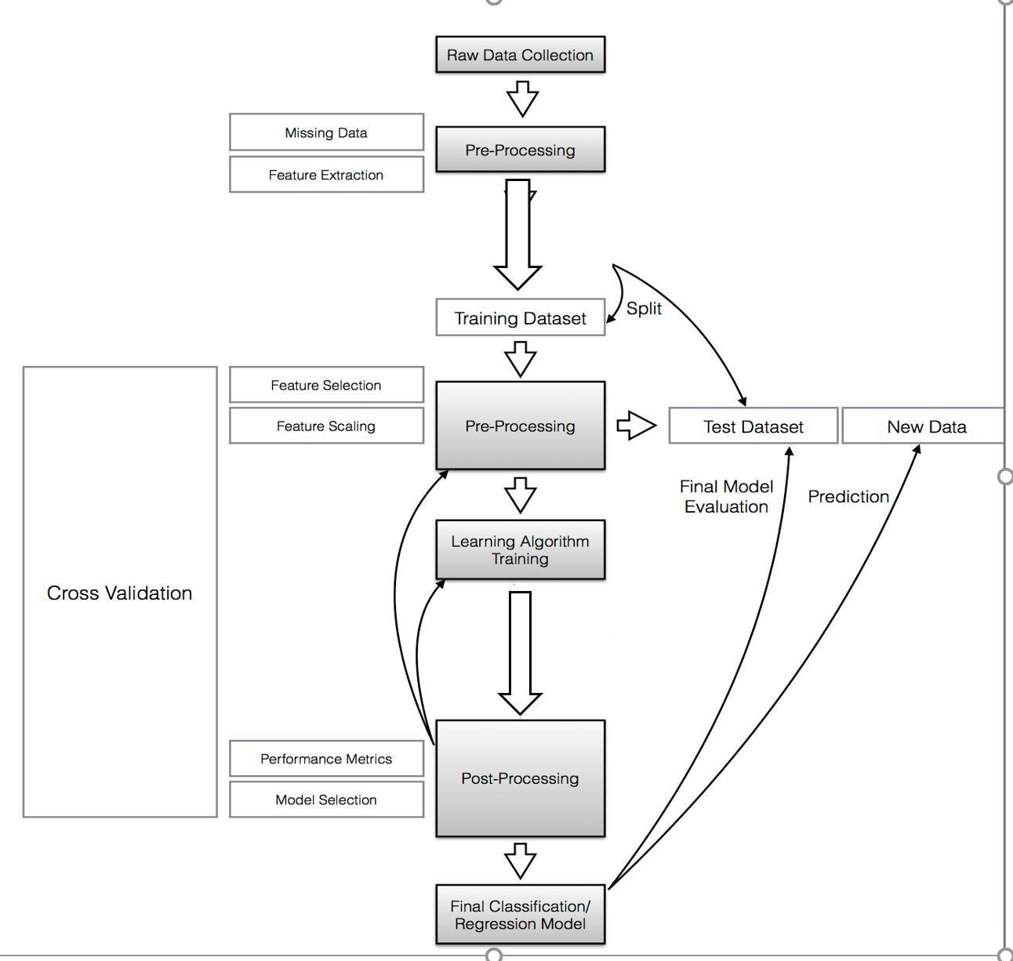

Fig:4.1 Data Flow Diagram

# UML DIAGRAMS

Unified Modelling Language is a standard language for writing software blueprints. The UML may be used to visualize, specify, construct and document the artifacts of a software intensive system. UML is process independent, although optimally it should be used in process that is use case driven, architecture-centric, iterative and incremental. The Number of UML Diagram is available

# Use Case Diagram:

Use case diagram is used to show which operations are performed by the user and which operation are performed by the system.

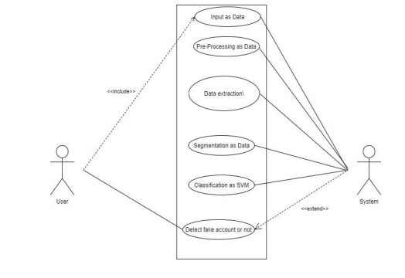

# Class Diagram:

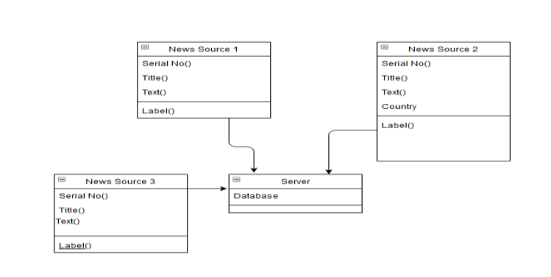

# Sequence Diagram:

In sequence diagram step by step sequence of steps is shown. In above diagram first pre-process all train data and test data. Then by applying the train data Train the machine and build the module and at the last apply machine learning algorithm on it. For testing purpose apply the test data on module and see the classification either fake or real.

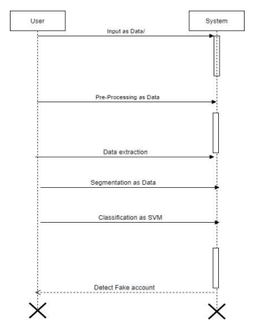

# Activity Diagram:

Activity Diagram shows the active flow of the system. In above diagram the flow of our project is shown actually how the data flow.

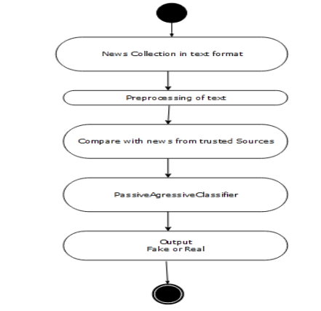

# Entity Relationship Diagram:

ER model stands for the Entity Relationship diagram in our project Dataset, Pre-processing, Train Machine, Machine Learning Algorithm, Build Module and Classification are the entities. Train data and test data are the attributes of Dataset. Feature extraction, stop word removal and steaming are attributes of the pre-processing.

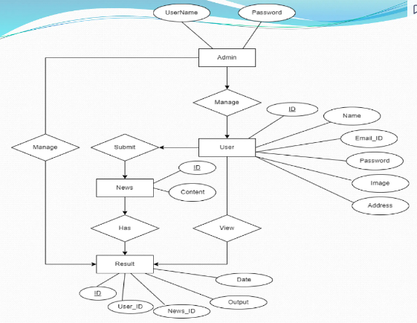

**TEST PROCEDURE**

# SYSTEM TESTING

The purpose of testing is to discover errors. Testing is the process of trying to discover every conceivable fault or weakness in a work product. It provides a way to check the functionality of components, sub-assemblies, assemblies and/or a finished product It is the process of exercising software with the intent of ensuring that the Software system meets its requirements and user expectations and does not fail in an unacceptable manner. There are various types of test. Each test type addresses a specific testing requirement.

# UNIT TESTING

Unit testing involves the design of test cases that validate that the internal program logic is functioning properly, and that program inputs produce valid outputs. All decision branches and internal code flow should be validated. It is the testing of individual software units of the application .it is done after the completion of an individual unit before integration. This is a structural testing, that relies on knowledge of its construction and is invasive. Unit tests perform basic tests at component level and test a specific business process, application, and/or system configuration. Unit tests ensure that each unique path of a business process performs accurately to the documented specifications and contains clearly defined inputs and expected results.

# INTEGRATION TESTING

Integration tests are designed to test integrated software components to determine if they actually run as one program. Testing is event driven and is more concerned with the basic outcome of screens or fields. Integration tests demonstrate that although the components were individually satisfaction, as shown by successfully unit testing, the combination of components is correct and consistent. Integration testing is specifically aimed at exposing the problems that arise from the combination of components.

## FUNCTIONAL TESTING

Functional tests provide systematic demonstrations that functions tested are available as specified by the business and technical requirements, system documentation, and user manuals.

Functional testing is centred on the following items:

Valid Input: identified classes of valid input must be accepted.

Invalid Input: identified classes of invalid input must be rejected.

Function: identified functions must be exercised.

Output: identified classes of application outputs must be exercised.

Organization and preparation of functional tests is focused on requirements, key functions, or special test cases. In addition, systematic coverage pertaining to identify Business process flows; data fields, predefined processes, and successive processes must be considered for testing. Before functional testing is complete, additional tests are identified and the effective value of current tests is determined.

### **WHITE BOX TESTING**

White Box Testing is a testing in which in which the software tester has knowledge of the inner workings, structure and language of the software, or at least its purpose. It is purpose. It is used to test areas that cannot be reached from a black box level. Black Box Testing is testing the software without any knowledge of the inner workings, structure or language of the module being tested. Black box tests, as most other kinds of tests, must be written from a definitive source document, such as specification or requirements document, such as specification or requirements document. It is a testing in which the software under test is treated, as a black box. You cannot “see” into it. The test provides inputs and responds to outputs without considering how the software works

# ACCEPTANCE TESTING

User Acceptance Testing is a critical phase of any project and requires significant participation by the end user. It also ensures that the system meets the functional requirements.

**CHAPTER 5**

## CONCLUSION AND FUTURE WORK

**CONCLUSION**

Many people consume news from social media instead of traditional news media. However, social media has also been used to spread fake news, which has negative impacts on individual people and society. In this paper, an innovative model for fake news detection using machine learning algorithms has been presented. This model takes news events as an input and based on twitter reviews and classification algorithms it predicts the percentage of news being fake or real.

**FUTURE WORK**

The feasibility of the project is analysed in this phase and business proposal is put forth with a very general plan for the project and some cost estimates. During system analysis the feasibility study of the proposed system is to be carried out. This is to ensure that the proposed system is not a burden to the company. For feasibility analysis, some understanding of the major requirements for the system is essential. This study is carried out to check the economic impact that the system will have on the organization. The amount of fund that the company can pour into the research and development of the system is limited. The expenditures must be justified. Thus the developed system as well within the budget and this was achieved because most of the technologies used are freely available. Only the customized products had to be purchased.

## REFERENCES

[1]. Parikh, S. B., & Atrey, P. K. (2018, April). Media-Rich Fake News Detection: A

Survey. In 2018 IEEE Conference on Multimedia Information Processing and Retrieval (MIPR) (pp. 436-441). IEEE.

[2]. Conroy, N. J., Rubin, V. L., & Chen, Y. (2015, November). Automatic deception detection: Methods for finding fake news. In Proceedings of the 78th ASIS&T Annual Meeting: Information Science with Impact: Research in and for the Community (p.

82). American Society for Information Science.

[3]. Helmstetter, S., & Paulheim, H. (2018, August). Weakly supervised learning for fake news detection on Twitter. In 2018 IEEE/ACM International Conference on Advances in Social Networks Analysis and Mining (ASONAM) (pp. 274-277). IEEE.

[4]. Stahl, K. (2018). Fake News Detection in Social Media.

[5]. Della Vedova, M. L., Tacchini, E., Moret, S., Ballarin, G., DiPierro, M., & de Alfaro, L. (2018, May). Automatic Online Fake News Detection Combining Content and Social Signals. In 2018 22nd Conference of Open Innovations Association (FRUCT) (pp. 272-279). IEEE.

[6] Tacchini, E., Ballarin, G., Della Vedova, M. L., Moret, S., & de Alfaro, L. (2017). Some like it hoax: Automated fake news detection in social networks. arXiv preprint arXiv:1704.07506.

[7]. Shao, C., Ciampaglia, G. L., Varol, O., Flammini, A., & Menczer, F. (2017). The spread of fake news by social bots. arXiv preprint arXiv:1707.07592, 96-104.

[8]. Chen, Y., Conroy, N. J., & Rubin, V. L. (2015, November). Misleading online content: Recognizing clickbait as false news. In Proceedings of the 2015 ACM on Workshop on Multimodal Deception Detection (pp. 15-19). ACM.

[9]. Najafabadi, M. M., Villanustre, F., Khoshgoftaar, T. M., Seliya, N., Wald, R., & Muharemagic, E. (2015). Deep learning applications and challenges in big data analytics. Journal of Big Data, 2(1), 1.

[10]. Haiden, L., & Althuis, J. (2018). The Definitional Challenges of Fake News.

## APPENDIX

**A) SOURCE CODE**

import string

import nltk

from nltk.stem import PorterStemmer

from nltk.corpus import stopwords

from sklearn.feature_extraction.text import CountVectorizer

import numpy as np

import torch

from app.models import Pickle_model, Fake_news_classifier_model

class Preprocessor_controller():

    def __init__(self, vectorizer_path, device='cpu'):

        self.vectorizer_path = vectorizer_path

        self.device = device

        self.__init_stemmer()

        self.__init_vectorizer()

    def get_vectorizer_vocab_size(self):

        return len(self.vectorizer.vocabulary)

    def __init_stemmer(self):

        nltk.download('stopwords')

        stop = set(stopwords.words('english'))

        punctuation = list(string.punctuation)

        stop.update(punctuation)

        self.stopwords = stop

        self.stemmer = PorterStemmer()

    def __init_vectorizer(self):

        pickle_model = Pickle_model()

        vocabulary = pickle_model.get_pickle(path=self.vectorizer_path)

        self.vectorizer = CountVectorizer(stop_words='english', vocabulary=vocabulary)

        self.vectorizer._validate_vocabulary()

    def __stem_text(self, text):

        final_text = [self.stemmer.stem(word.strip()) for word in text.split() if word.strip().lower() not in self.stopwords]

        return " ".join(final_text)

    def __vectorize_text(self, text):

        return self.vectorizer.transform(text)

    def __csr_to_tensor(self, csr):

        coo = csr.tocoo()

        values = coo.data

        indices = np.vstack((coo.row, coo.col))

        i = torch.LongTensor(indices)

        v = torch.FloatTensor(values)

        shape = coo.shape

        return torch.sparse.FloatTensor(i, v, torch.Size(shape))

    def transform(self, text_articles, article_titles):

        text = text_articles if isinstance(text_articles, list) else [text_articles]

        titles = article_titles if isinstance(article_titles, list) else [article_titles]

        inputs = [title + " " + text for (title, text) in zip(titles, text)]

        stemmed_text = [self.__stem_text(text) for text in inputs]

        print("Stemmed_text: {}".format(stemmed_text))

        vector = self.__vectorize_text(stemmed_text)

        print("Vector: {}".format(vector))

        tensor = self.__csr_to_tensor(vector)

        print("Tensor: {}".format(tensor))

        return tensor.to(self.device)

class Fake_news_classifier_controller():

    def __init__(self, model_path, in_features, device='cpu'):

        self.model_path = model_path

self.model=Fake_news_classifier_model(in_features=in_feates).to(device)

        self.model.load_model(path=model_path, device=device)

        self.model.eval()

    def __predict_tensor(self, tensor):

        pred = self.model(tensor)

        return pred

    def predict(self, tensor):

        prob_list = self.__predict_tensor(tensor).tolist()

        print("Confidence: {}".format(prob_list))

        return [{'real':{'label':'Real', 'value':real_prob}, 'fake':{'label':'Fake', 'value':fake_prob}} for real_prob, fake_prob in prob_list]

**RUN.py**

from app import app

if __name__ == '__main__':

    app.run(debug=True)

## B) SCREENSHOTS

Fig:5.1 Admin Page

OUT PUT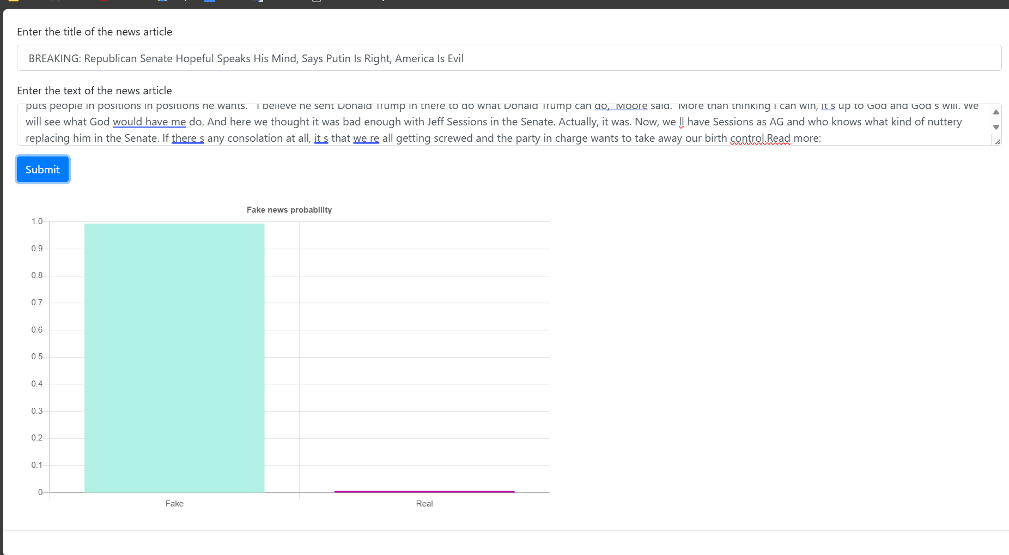

Detecting Fake News using Dataset

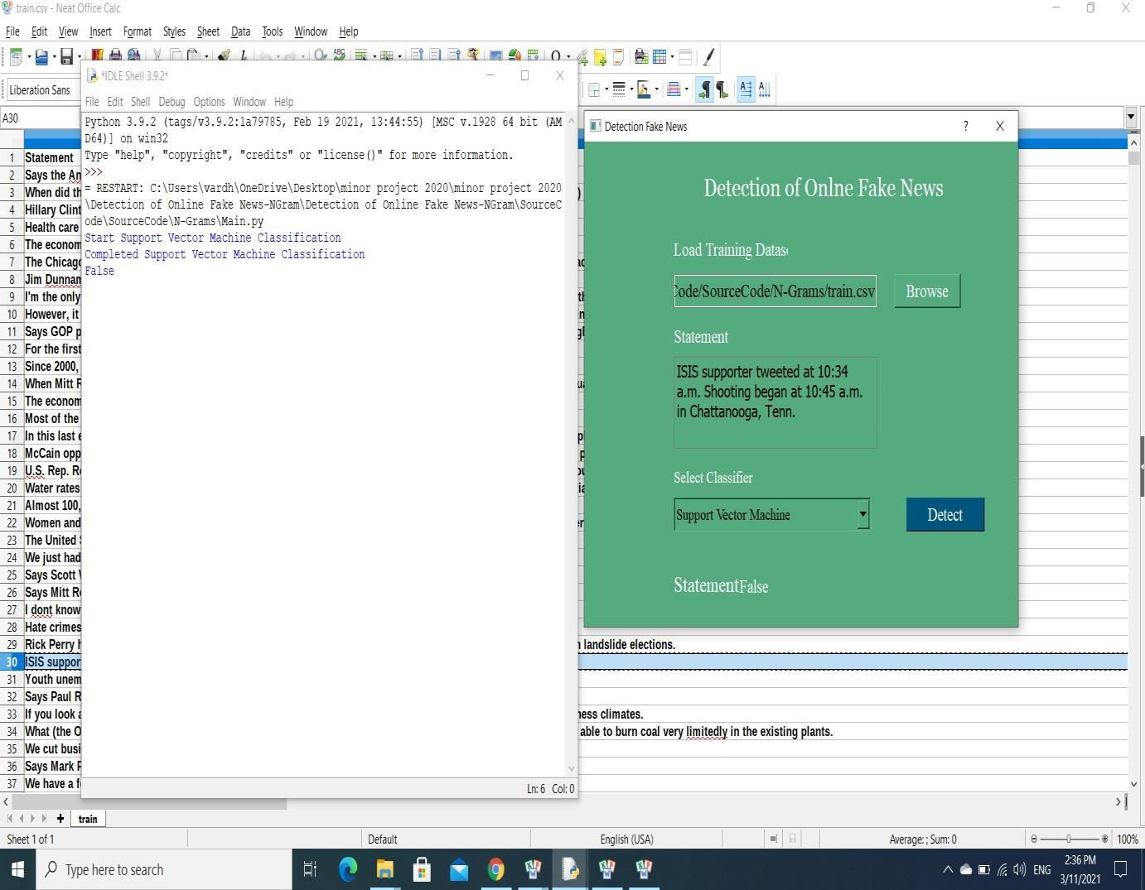

### Checking statement with Dataset